Fernando Becerra

IT 3212 u04a01

02/03/2019

Assignment 4

Github url:

https://fernandofernz.github.io/3212.u04a01/pages/gallery.html

Chrome Developer Tools:

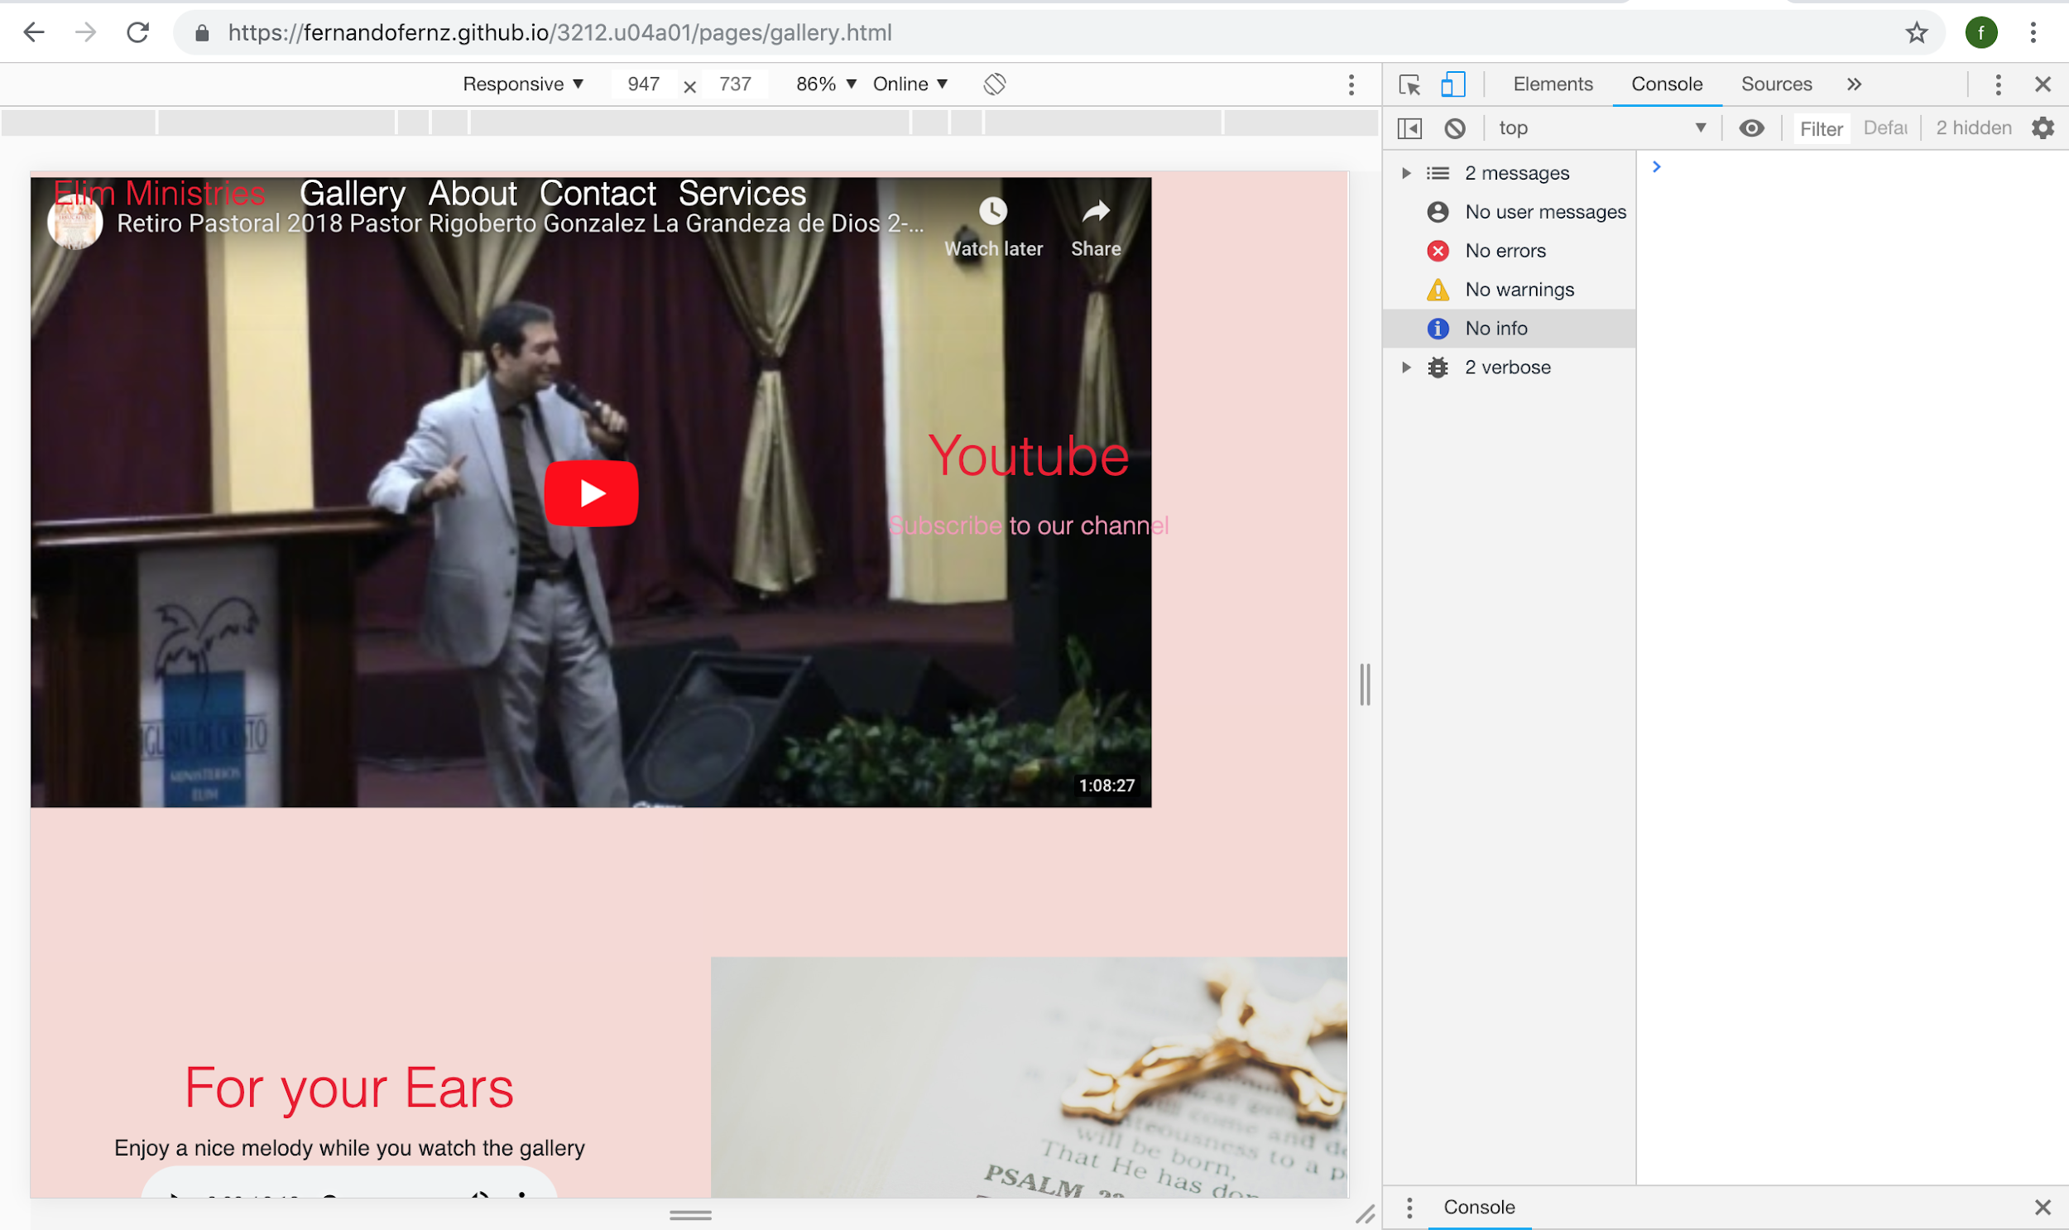

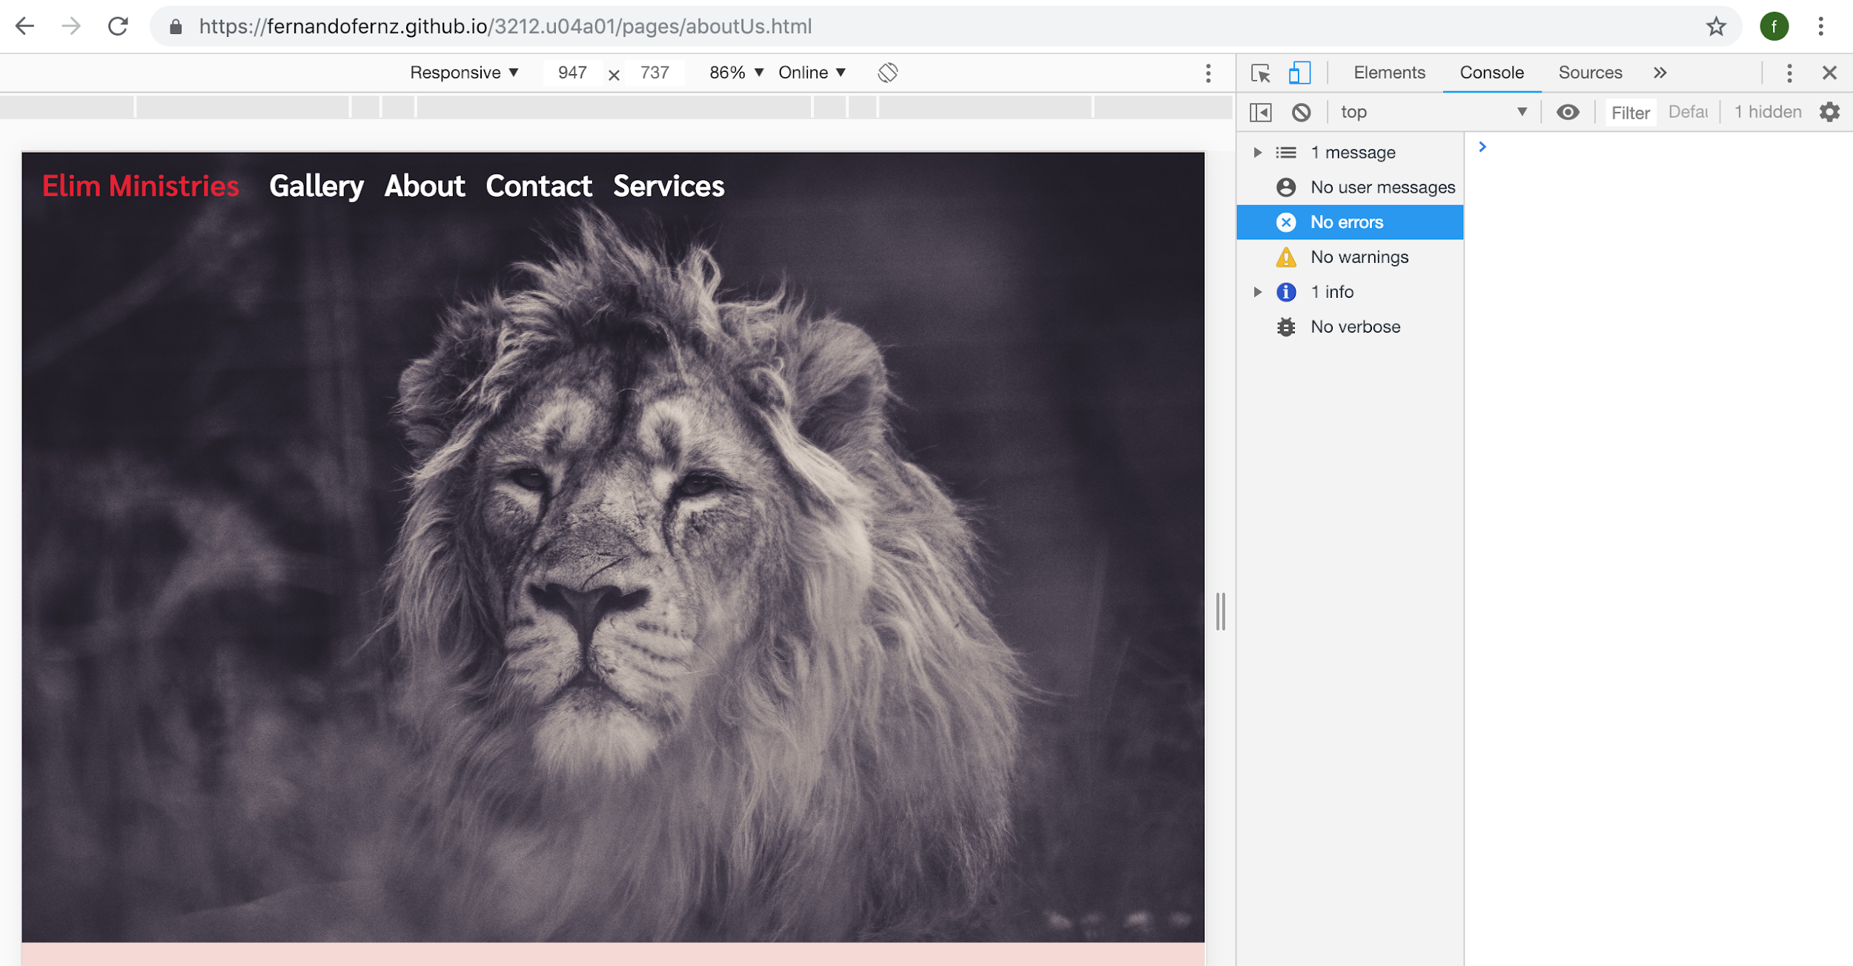

Safari Web Inspector Tools:

